ECE312 Communication Networks

Ryan Oberlitner & Scott Cai

Project 2 – Packet Encapsulation

The source codes contain several C programs. To run the program, you need to compile client.c and run it.

Our program sent three messages in three different steps, but we always get one of messages received checksum wrong. We verify every checksum for the messages we received to see if it meets the correct checksum, as well as print out the messages. For the source port, we are using CM #2256, and the id we received on the last step is 22453995 (we interpreted it after multiply and add them together).

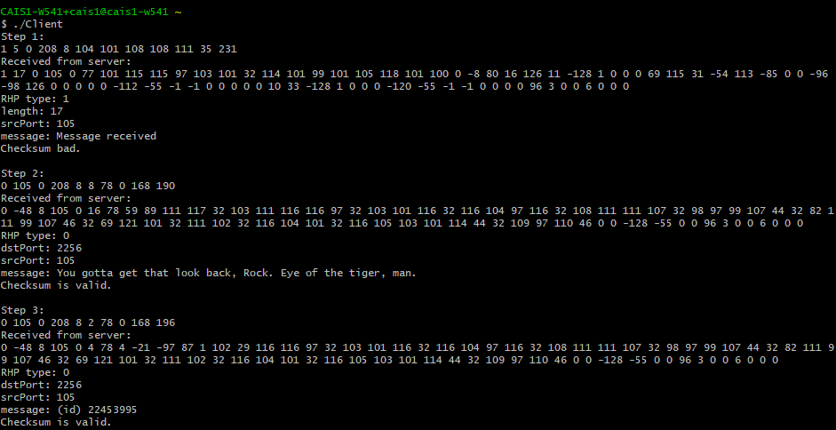

Figure Messages we received from three steps, only the first message we received does not meet the checksum